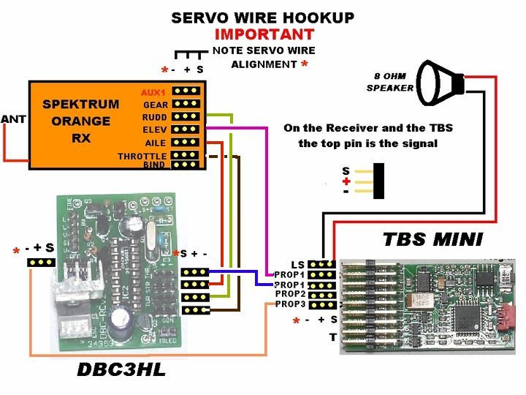
You have received the complete package above. All you need to do is hook up the three wire cable from the RX 18 to the DBC, and your speaker to the TBS mini. The upper two output pins are used for the speaker.
The Orange receiver has a bind plug installed. You need this to bind the receiver to your Spektrum radio. Once the receiver has been binded to your radio( Check your radio instructions on how to do this) remove the bind plug. Shut down and restart system WITHOUT the bind Plug.
User selectable options are available to select prior to starting the tank. Familiarize yourself with the operating instructions of the DBC3 to fully understand and utilize the options available to you. The DBC3 operates exactly like a DBC2 except it has been configured to work with the Benedini TBS. The recoil ouput on the DBC3 is now used for this interface, and therefore you do not have the Servo recoil option. The link below will take you to the operating manual.
http://darkith.dyndns.org/~darkith/files/DBC-RC2HL_inst.pdf
Also connected to the DBC board is a Gun Flash, and an IR LED. LEDs require the correct polarity to function. As the plugs are not auto orientating it is possible to have the polarity the wrong way. In the event you don’t get a flash, just flip the plug 180 Degrees, and try again. No harm can come to the LED’s if you guess wrong. OF course IR light is invisible, but you still need to have the correct polarity for it to fire. IF for any reason your IR shot is not firing, check the plug and try flipping it 180 degrees as well
Complete user instructions for the DBCRC and the Benedini are available as links from my website. Instructions on programming sound are available at the Benedini website. You must download the Benedini software, and then use the USB programming cable to link to the TBS.
This purchase is one of the easiest ways to improve the sound quality on a Heng Long tank. Enjoy your purchase and take in the superior sound. When you are ready for IR battling you will need to add and IR sensor. Below is a diagram to help you orientate the HBU sensor I sell and use it with your DBC3
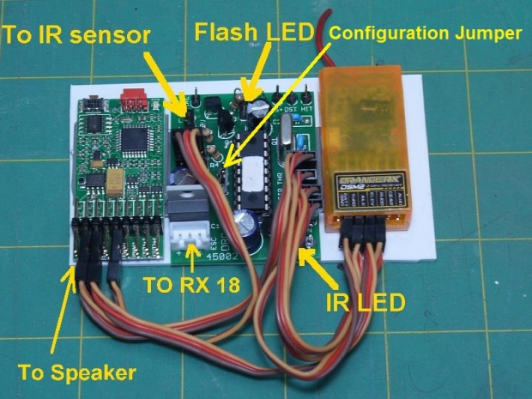
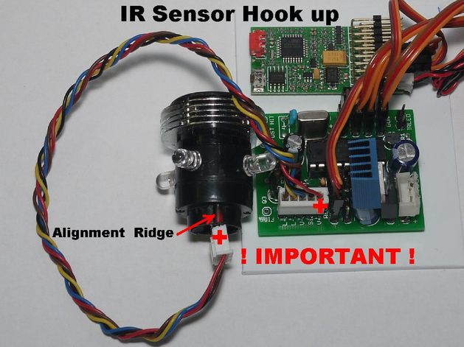
In the event you are using an Tamiya sensor please refer to the picture below
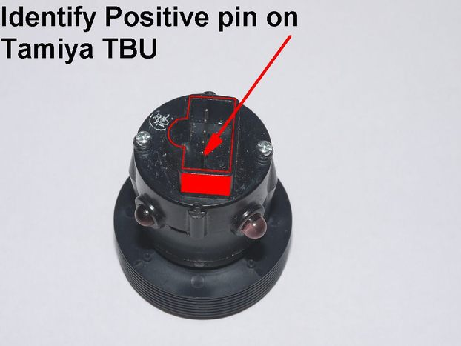
IF you have any questions don’t hesitate to ask
Thanks
Dan

TBS – DBC3 Interaction Directions

Configure the TBS Parameter settings as follows:
Prop1 Input: RC
Prop1 Type: Gas
Prop3 Input: RC
Prop3 Type: 1st Coder 12-key

Engine Type: man. Start

Coder Functions:
1 Engine Start
2 Sound 1
3 Sound 2
4 Sound 3
5 Sound 4
6 Sound 5
7 Sound 6

Then build a sound file with the following sound effects:
Engine sounds M1-M6
Sound 1: Cannon HIT
Sound 2: Tank destroyed
Sound 3: Cannon Fire
Sound 4: MG Fire
Sound 5: Turret Rotation
Sound 6: Elevation change

Get the tank running normally with the DBC-RC3HL (set any channel reversing, get trims set, etc). You may want to make note of the throttle values where the tank starts moving and hits max speed for later.

Then hookup the TBS:
1) The throttle channel from the RX goes into Prop1 Input on the TBS
2) Prop1 Output on the TBS goes into the DBC3 throttle channel
3) The "OUT" channel on the DBC3 goes into Prop3 on the TBS
4) Speaker plugged directly into TBS

Configure the TBS to understand the DBC-RC3HL sound signals. Place the "CFG" jumper on the DBC3 board and power up.

1) Push the throttle up to save the hardware config (no changes from last setup) and exit the HW config mode. Now we're in sound config mode.

2) Press and hold the button on the TBS until it beeps and the LED lights up.

3) Move the throttle channel to the desired "acceleration start" (barely off neutral)
point. While holding this position, push the Turret stick all the way up and then return to center. The TBS should beep and play a short accelerate clip

4) Move the throttle channel to the desired "full throttle" point.( 3/4 up)
While holding this position, push the Turret stick all the way down and then return to center. The TBS should beep and play a short full throttle clip

5) The DBC will now automatically step through the six sound effects, programming the TBS to recognize them. It should play a short burst each of effect followed by a beep, taking about 5 seconds.

6) Once this completes, the TBS will still have the LED on solid.

Turn off the tank, remove the CFG jumper on the DBC3, and you're good to go.

